STAYING LEAN & MEAN
Can be challenging
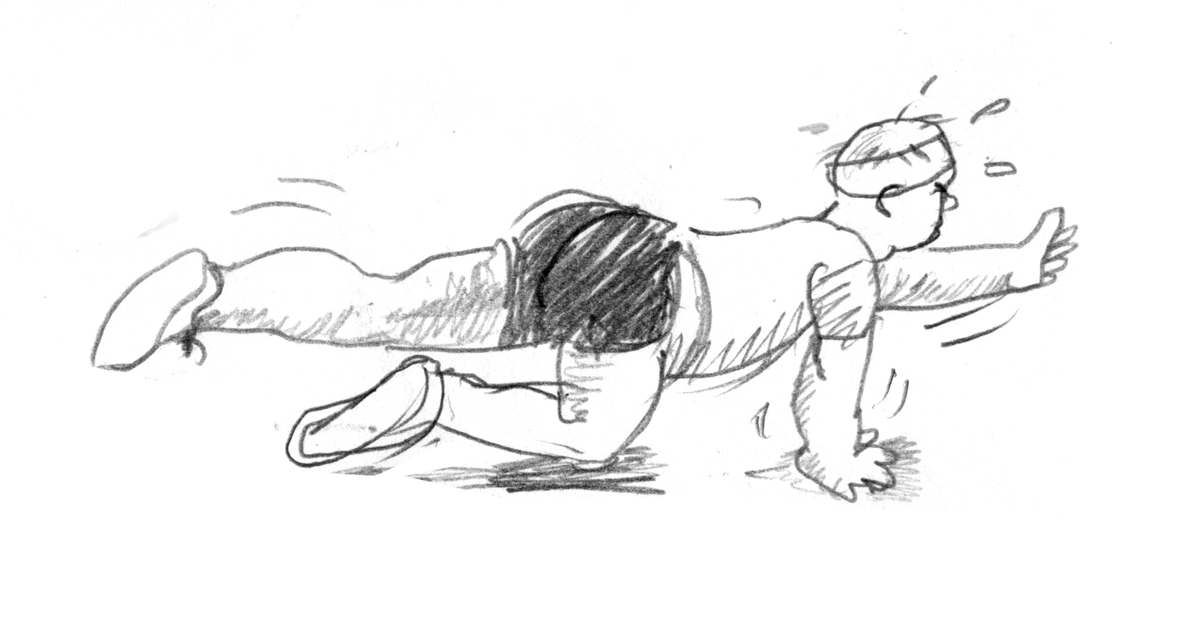
(Image in color)
But we can help…
Thermosleeve-USA offers a comprehensive range of tubing in various colors and shrink ratios. Our products are manufactured under TS16949 Quality System and ISO14001/IS9001 Environment System certifications and are produced to meet or exceed UL/224/MIL approval requirements. Thermosleeve-USA products are also certified under the following agencies F-Mark, CSA, TUV, VDE, UL/C-UL and are registered “Green Partners” with Sony and Samsung Electronics.

If you’re manufacturing wire harnesses, rest assured Thermosleeve-USA probably offers a tubing to meet your project requirements. Meeting those requirements is important to us and we certainly welcome the opportunity to provide you with further information regarding our selection of heat shrink and non-heat shrink tubing products, including value added capabilities such as custom printing, cutting, bagging and labeling, and stay on budget and on time.

Our website (www.thermosleeve-usa.com) or online catalog (www.thermosleeve-usa.com/catalog) have additional information regarding our product line.
Contact us at (800) 421-3536; we are available Monday through Friday from 8 AM to 5 PM PST and ask for your free tubing sample pack (photo of sample pack?).

At Thermosleeve-USA, we are tubing and we want to help you stay lean & mean.
(logo)

footer info…

